Kiribati Disability fact sheet
Source: Kiribati 2020 Population and Housing Census
SPC, 2025

DEMOGRAPHICS
- Population aged 5+: 99,466
5,559 peoples with disabilities
- Sex ratio (5+): Kiribati population is sightly dominated by females: 96 males for 100 females
- Median age (5+)
People with disabilities: 53 years
People without disabilities: 29 years

- Distribution of the population aged 5+ by sex and disability status
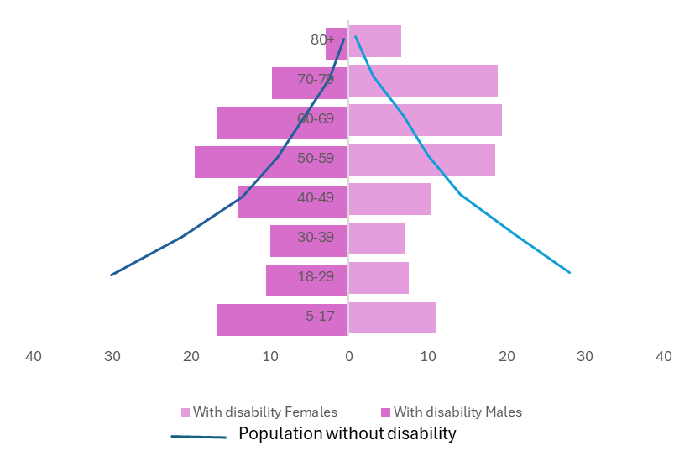
PREVALENCE
- Percentage of people aged 5+ with disabilities is 5.6% in 2020 (3.1% in 2015).
- Prevalence of disability increases with age, from 2% among those aged 5-17 years to 62% among those aged 80+.

- Prevalence by type of disability, 5+ years
  - Females (6%) are more likely than males (5%) to report having disabilities
  - Walking is the most common type of disability reported within the population
 | Walking | Seeing | Hearing | Remembering | Selfcare | Communication
Total | 3% | 1% | 1% | 1% | 1% | 1%


People with disabilities are more likely to live in households with the lowest quintile of wealth: the disability prevalence rate is 7% in lowest quintile vs 4% in highest quintile

EDUCATION 
- People who ever attended school Youth 15-24 who ever attended school school, 15+ years
Without disability with disability Without disability with disability
Males 98% 89% 99% 80%
Females 98% 86% 100% 77%

  - There is disparity in school attendance due to disability status: people with disability are disadvantaged

- Highest School level attended, 25+ years

  - People with disabilities aged 25+ are less likely to have attended secondary school and tertiary level education.

- People aged 15+ who can read and write (Literacy)
Total: 94% Without disabilities: 96% With disabilities: 73%
  - People aged 15+ with disabilities (73%) are less likely to be literate: 23 points behind
  - Youth aged 15-24 with disabilities are less likely to be literate
Total:96% Without disabilities: 96% With disabilities:62%

  - There is literacy equality between males and females regardless of disability status
LABOUR FORCE 

- Youth aged 15-24 not in Education, nor in Employment or Training – NEET (SDG 8.6.1)
  - In 2020, nearly 1 in 2 youths are neither in employment nor in education or training
  - Youth aged 15-24 with disabilities are more likely than their peers without disabilities to be NEET
Total: 47% Without disabilities:47% With disabilities:54%

- Labour force participation rate: Percentage of people aged 15+ who are working or looking for work on the working-age population
  - People aged 15+ with disabilities are 24 points behind people without disabilities in participation in the labour force

- 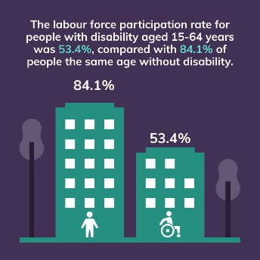

  - When classified as in the labour force, 1 in 2 people with disabilities worked on their own account

  - Main industry of own-account workers with disabilities
Market service Agriculture
With disabilities: 51% 35%
Without disabilities: 43% 48%

- Unemployment rate (SDG 8.5.2)
Include people available and seeking work on labour force: employed and unemployed

Total: 11% With disabilities: 7% Without disabilities:12%
The low unemployment rate of people with disabilities compared to people without disabilities is due to the fact that people with disabilities are much more outside the labour market: 75% of them, aged 15+ are outside the labour market compared to 46% of those without disabilities

WATER AND SANITATION
  - People aged 5+ with disabilities are slightly less likely to live in a household with access to improved water sources (SDG 6.1.1)
Total: 74% Without disabilities: 74% With disabilities: 71%

  - People aged 5+ with disabilities are slightly less likely to live in a household with access to sanitation facilities (SDG 6.1.2)
Total: 66% Without disabilities:66% With disabilities:60%

ACCESS TO INTERNET (SDG 17.8.1)
- People aged 10+ with access to internet
  - Slightly more than 1 in 10 people with disabilities had access to Internet the week before the interview in 2020
Total: 37% Without disabilities: 38% With disabilities:13%

  - Youth 10-24 years and adult 50+ with disabilities have less access to internet than their peer without disabilities

 | With disability | Without disability
10-24 | 17% | 36%
25-49 | 47% | 55%
50+ | 36% | 9%

  - Among those who had access to internet, most people (83%) had access to internet at home, regardless of disability status

DEFINITIONS
Defining Disability
No single definition of disability exists. Definitions vary depending on the purpose for measurement. Moreover, the nature and severity of disabilities can vary greatly depending on cultural contexts. Yet, data on the size and characteristics of the population with disability, which also allow for cross-cultural comparisons, require standardization in both the conceptualization and the measurement of disability. The International Classification of Functioning, Disability and Health classifies disability into three interrelated areas: Impairments, Activity limitations and Participation restrictions.
The Washington Group developed an extended set of survey items on functioning to be used as components of population surveys or as supplements to specialised surveys. These questions identify persons who are at a greater risk of experiencing restrictions in performing usual activities such as those undertaken in daily living or participating in roles if no accommodations are made.
DATA & METHODS
Disability was conceptualised as a continuum, from minor functioning difficulties to severe difficulties that significantly impact people’s lives. According to the WG recommendations, persons with disabilities are classified as anyone with at least one of six functioning domains declared as “a lot of difficulty” or “cannot do at all” as recommended by the Washington Group for international comparability.
This factsheet use data from the Kiribati population and housing census 2020. The six variables from the WG short set on functioning were combined to identify the population with disabilities. Variables for analysis was derived from these questions for persons aged 5+ years who had reported at least one domain as “a lot of difficulty” or “cannot do it at all” were identified as having disabilities, in accordance with the recommendations of the WG (Washington Group, 2009).
Data were disaggregated by disability status, for the comparison of people with and without disabilities, a necessary step towards addressing disparities. The Chi-Square Test of Independence have been carried out to examines that the sets of variables are likely to be related with each other or not (significance level p<0.05).

For further information
Kiribati disability monograph
(https://www.spc.int/digitallibrary/get/rtiav)
Pacific disability dashboard
(https://pacificdata.org/disability-dashboard)
WG definition and methods
(https://www.washingtongroup-disability.com/question-sets/wgshort-set-on-functioning-wg-ss/)

Improved sanitation facilities and drinking-water sources

